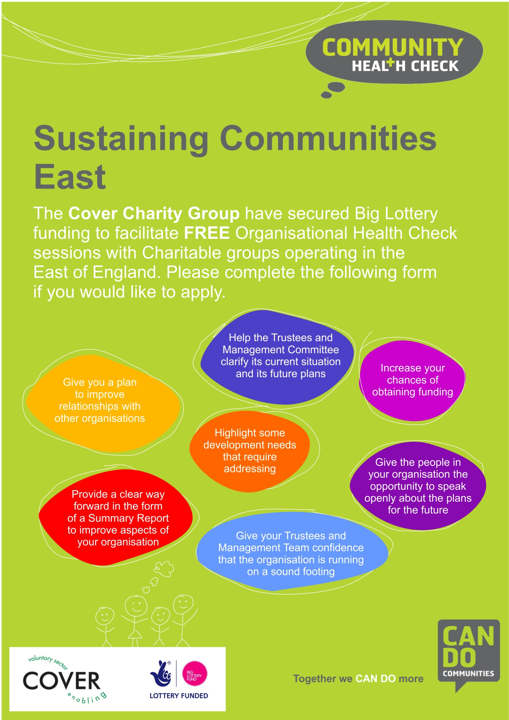
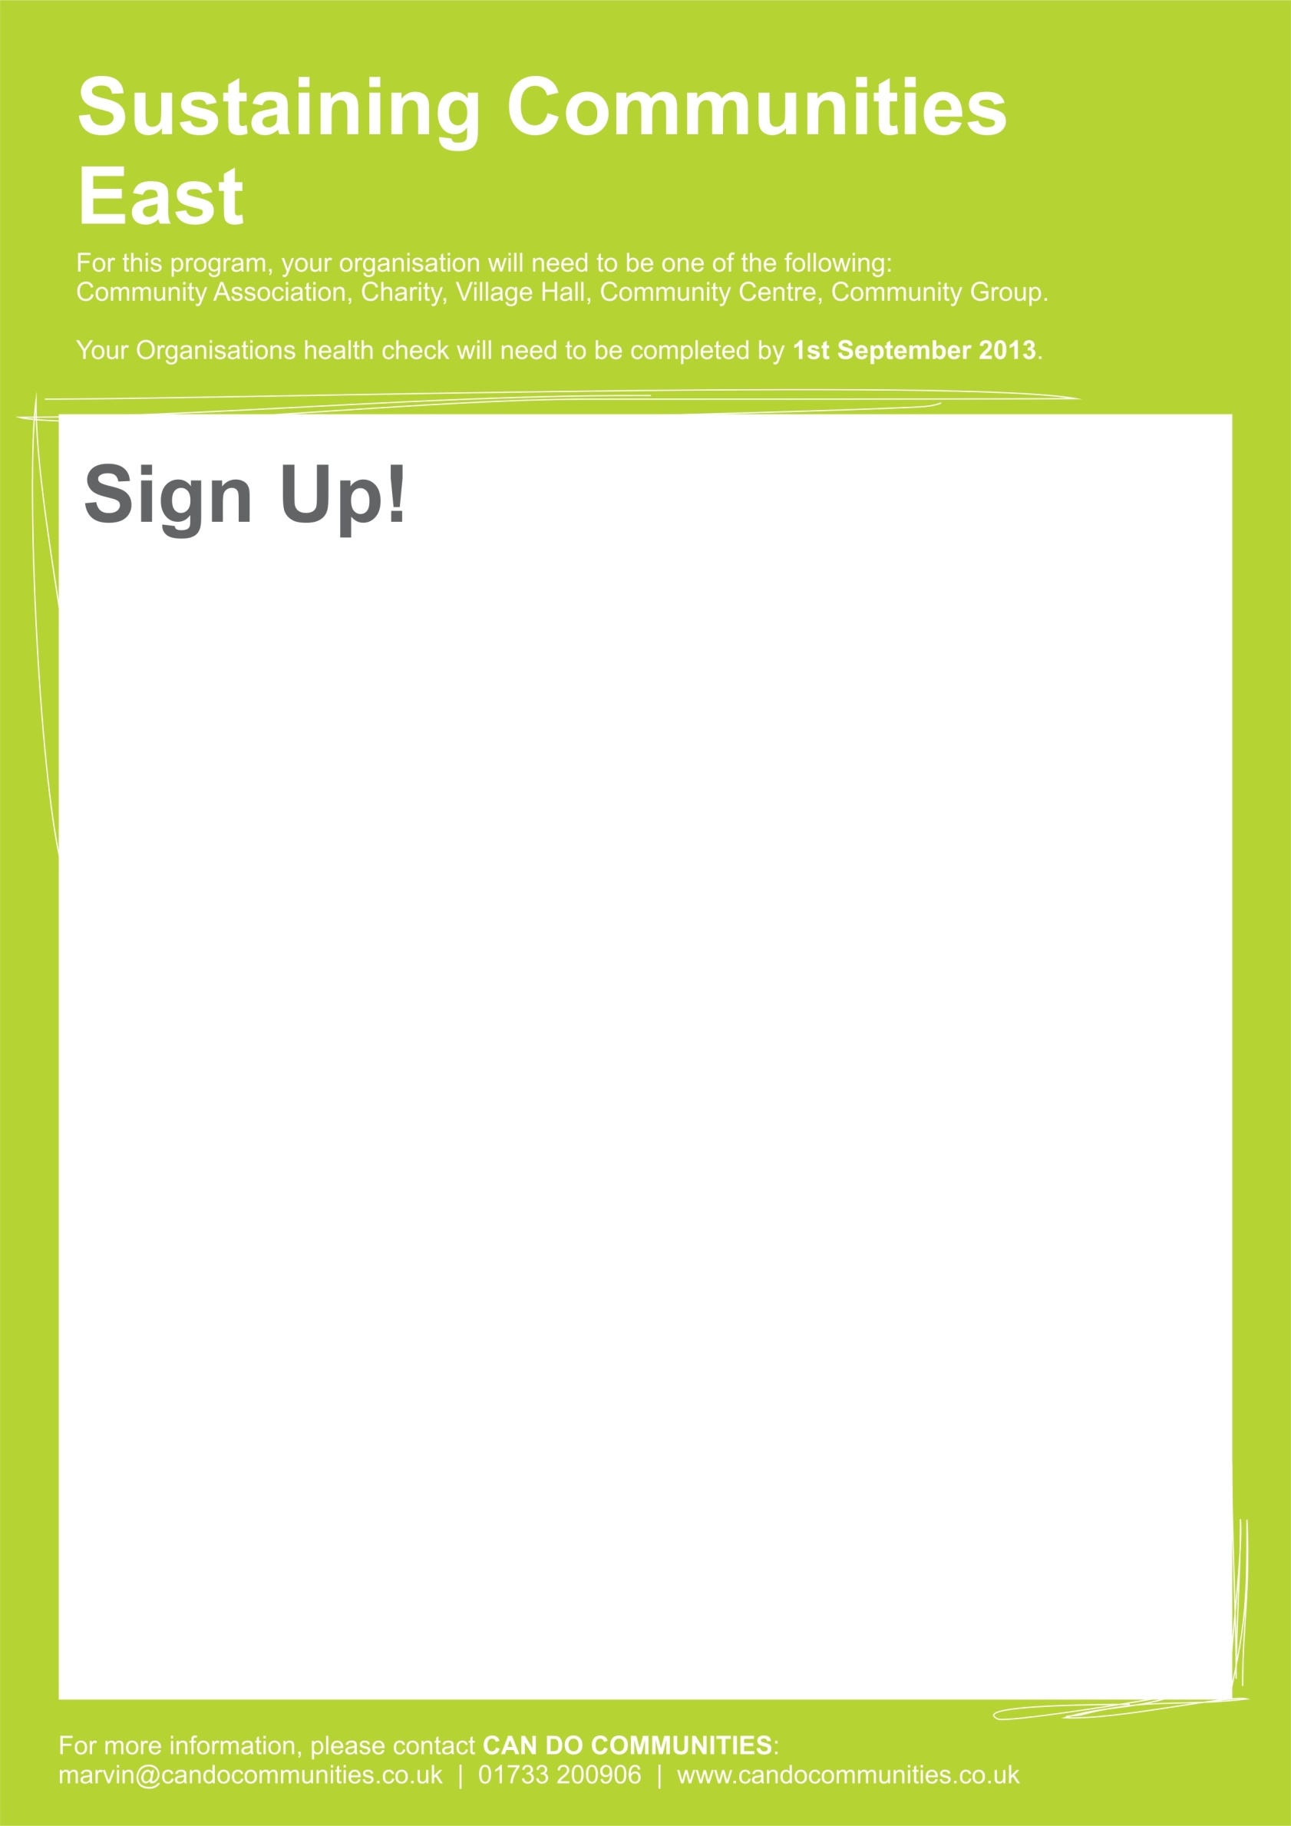
Please save this form and email to: marvin@candocommunities.co.uk

Name of Organisation: _________________________

Contact Name: Contact Number:

Address of Organisation:

Email Address: Website:

Short Description of your organisation (max 100 words):

Why are you applying for a Community Health Check? (max 100 words): _____________

